**Divisible Sum Pairs**

https://d3keuzeb2crhkn.cloudfront.net/s3_pub/hr-avatars/aeda8340-d6af-4f00-9aff-16617e8ba405/150x150.png**by [wanbo](https://www.hackerrank.com/wanbo)**

* [**Problem**](https://www.hackerrank.com/challenges/divisible-sum-pairs)
* [**Submissions**](https://www.hackerrank.com/challenges/divisible-sum-pairs/submissions)
* [**Leaderboard**](https://www.hackerrank.com/challenges/divisible-sum-pairs/leaderboard)
* [**Discussions**](https://www.hackerrank.com/challenges/divisible-sum-pairs/forum)
* [**Editorial**](https://www.hackerrank.com/challenges/divisible-sum-pairs/editorial)

You are given an array of  integers, , and a positive integer, . Find and print the number of  pairs where  and  +  is evenly divisible by .

**Input Format**

The first line contains  space-separated integers,  and , respectively.   
The second line contains  space-separated integers describing the respective values of .

**Constraints**

**Output Format**

Print the number of  pairs where  and  +  is evenly divisible by .

**Sample Input**

6 3

1 3 2 6 1 2

**Sample Output**

5

**Explanation**

Here are the  valid pairs:

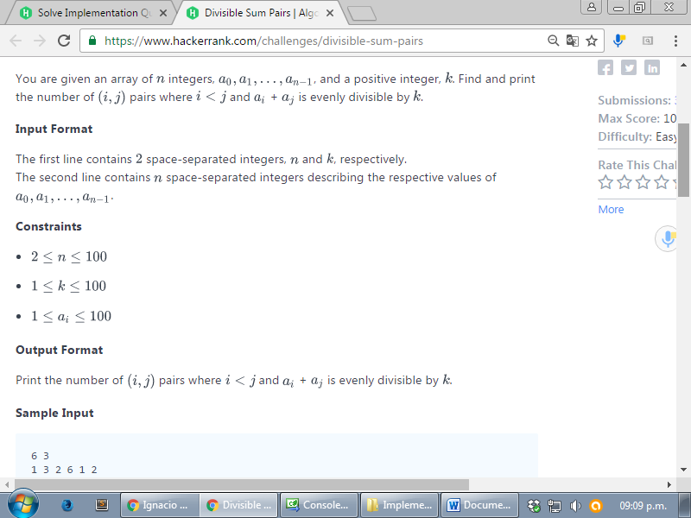

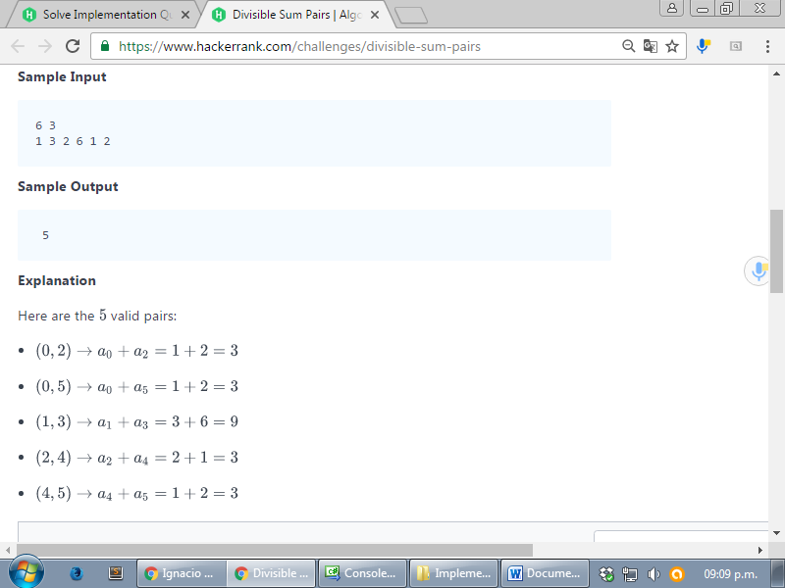

<https://www.hackerrank.com/challenges/divisible-sum-pairs>

using System;

using System.Collections.Generic;

using System.Linq;

using System.Text;

namespace ConsoleApplication1

{

class Program

{

static void Main(string[] args)

{

string[] tokens_n = Console.ReadLine().Split(' ');

int n = Convert.ToInt32(tokens_n[0]);

int k = Convert.ToInt32(tokens_n[1]);

string[] a_temp = Console.ReadLine().Split(' ');

int[] a = Array.ConvertAll(a_temp, e => int.Parse(e));

int ans = 0;

for (int i = 0; i < n-1; i++)

{

for (int j = i + 1; j < n; j++)

{

if ((a[i] + a[j]) % k == 0)

{

ans++;

}

}

}

Console.WriteLine(ans);

Console.ReadLine();

}

}

}